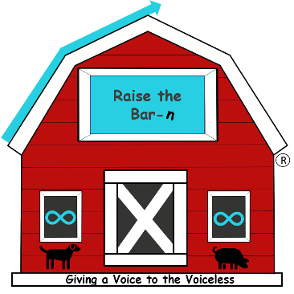

[www.raisethebarnrescue.org](http://www.raisethebarnrescue.org) - Raise the Bar-N Foundation - (702) 287-7133

Raise the Bar-N Adoption/Foster Interest Form

Date: _____________

Applicant First and Last Name: __________________________________________________

Birth Date: __________________________________________________________________

Address: __________________________________ City:_____________ Zip Code_________

Phone: _____________________________________________________________________

Email: ______________________________________________________________________

What type of animal are you interested in (circle): dog cat guinea pig rabbit chicken waterfowl peafowl tortoise turtle mini pig Other________________________________

Name/breed of animal you are interested in if applicable): _____________________________

Personality: (calm, energetic, affectionate, etc.): ____________________________________________________________________________________________________________________________________________________________

Color: _______________ Sex: _________________ Approximate Age: __________________

How many people currently reside in your household: __________________________________

Any Children (list ages):___________________________________________________________

Does any member of the family have allergies: ________________________________________

Who will be responsible for the animal’s care: ________________________________________

What kind of dwelling do you live in (house, condo, apartment): _________________________

Do you own or rent: ________________ Landlord’s number (if applicable): ________________

Do you have a fenced yard: yes no What type (brick wall, chain link, metal fence, etc):_____________________

Do you have a pool: yes no Do you have a fence around the pool: yes no

Are you familiar with local animal control laws: yes no

If you have other dogs, do you know how to properly introduce a new dog?  yes    no

Here is a link about introducing new dogs: <https://www.humanesociety.org/resources/introducing-new-dogs>

Will you ensure vaccinations will remain up to date at all times: yes no

Please tell us a little about your lifestyle so we can pair you with the most appropriate animal: ____________________________________________________________________________________________________________________________________________________________________________________________________________________________________________________________________________________________________________________________________________________________________________________________________________________________________________________________________________________

Please be aware that there are some restrictions with home insurance companies that may prohibit the ownership of certain breeds. Please check with your insurance company.

By signing this form, I/we acknowledge that all information on this form is true and correct. I/we understand that any misrepresentation of fact may result in “Raise the Bar-N Foundation” refusing adoption/fostering privileges to me/us. If the “Raise the Bar-N Foundation” discovers that any of the aforementioned information is false, the “Raise the Bar-N Foundation” reserves the right to remove the adopted/fostered animal from my home/farm.

Adopter Signature: _________________________ Printed Name: ________________________